Project – AI/ML

Project Name: AI Colorisation

Project Duration: 6 Months

Description: Using Machine Learning we have developed a model which colorize a Black and White Images.

|  |  |
| --- | --- |
| August 2018 to January 2019 |  |

*Under the*

*Guidance of Team Drishti we*  *have made this project.*

*- Team AI*

*Project Members: - Mentor’s Name:-*

*Gulshan Rana Mansi Sampat*

*Sarvesh Dubey Deval Pandya*

PROJECT DESCRIPTION

COLORISATION as the name suggests something related to colors. But what is the project about. Let’s say if you want to color any black and white image: Ok that’s an easy task if the picture would be colored in any sense. But if we tell you tell you to colour the picture as it would have been if we would have taken a colored picture then it might seem tough and also its tough to color without knowing the situation or the moment in which the picture was taken. Now think how wonderful it be if you have a model that automatically fills the color in the photo. May seem awesome right. We at Drishti have built a model based on Machine Learning that could colorize images without any human effort. Let me take you to a ride how we have built this model.

Phases

1. LEARNING PHASE

A. COURSES

# B. MATERIALS

# 2. DATASET PHASE

# 3. MAKING OF DATASET

# 4. NN PHASE

# 5. ALPHA VERSION

# 6. BETA VERSION

# 7. NEED OF GPU

# 8. TUNING PHASE

learning phase:

Courses:

As the project required deep knowledge of Machine Learning we were required to do Deep Learning Courses and a Framework Course:

Courses Followed are:

1. Deep Learning by Andrew NG (This basically included 5 courses and itself is a Specialization Course on Deep Learning)

2. Medium Courses on Neural Networks and its applications

3. Frameworks we followed was TensorFlow(Googles Deep Learning Framework)

# Materials used

We used Google Collab whenever during any course we required as its best suited for doing Deep Learning works and also got familiar with

GOOGLE CLOUD PLATFORM which provides

GPU access for a limited time for an account.

# Dataset phase

IMPORTANCE OF DATASET

As we know that Machine Learning is purely based on inputs of data and learning from the Data itself the Dataset phase cannot be neglected as it forms the whole and heart of the project and the whole model depends on the Quality of Dataset

What do we mean by the quality of Dataset and why is it important?

Dataset is the collection of important information that we feed into the Machine Learning Model and thus we train the model to predict on the unknown data

Our Dataset:

It’s a Custom Dataset that is made by taking other datasets and combining them all.

So initially we had lots of Colored image that is converted to black and white pictures and are used for training of the data and some black and white pictures are left for testing of our model

So, for making of dataset we have used Python lib OpenCV to convert to black and white image and directly store it in a folder

But as we know Dataset is not so easy to be created as it depends on various factors such as:

1. Data Augmentation
2. Data Cleaning
3. Data Collection (MOST INITIAL)
4. Data Compression Techniques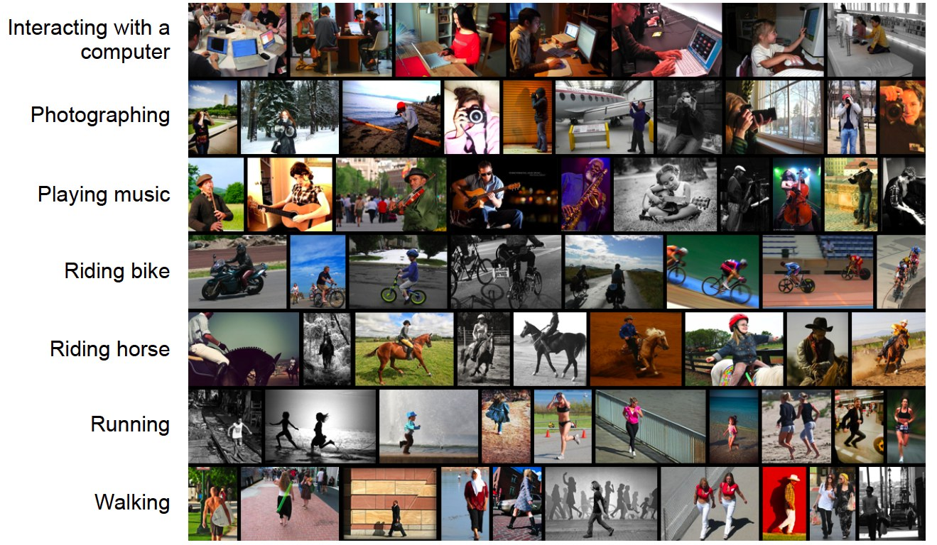

So, what we did in order to get a Clean and Quality Data:

Our created Dataset contained around 25k images but it was not enough to train a well accurate model so we search for an open source Dataset and we found one on the Medium website and combine various datasets.

NN PHASE:

Now as we knew that after we have a dataset created, we would have to have a proper model on which dataset can be fed and we get a proper and accurate output

NN PHASE - (Neural Network Phase)

Different Algorithms work differently and have their own benefits. But training a model with the help of Neural Network can increase efficiency of model (here efficiency co-relates to accuracy) and helps in fine tuning the model.

# 

# CNN - the neural brother

CNN also known as Convolutional Neural Network is a kind of Neural Networks for Images thus is also considered as Computer Vision by Andrew Ng. Now as we are working with images, we will be using Neural Network for the purpose.

Now what the CNN does is treats the image as an RGB channel and applies Neural Network accordingly on different blocks of channel also knows pooling process (max pooling).

Not covering the deep aspects how the process goes on in the CNN we will now discuss the different phases that we undergo during the whole project

# ALPHA PHASE

DESCRIPTION

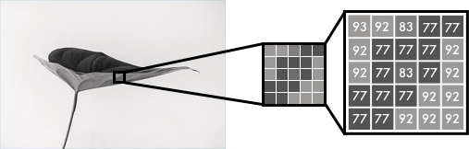

Consider any black and white image so if we want to represent it as an array or matrix, we can do it by considering pixel intensity.

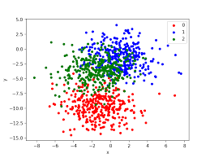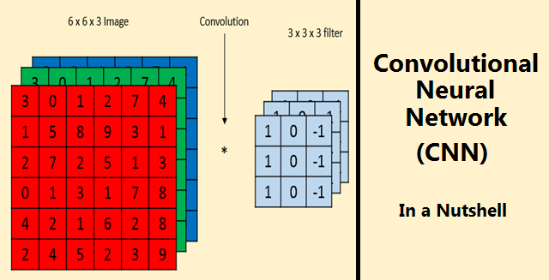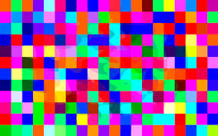

Same logic goes for the colored images which can considered as a 3d Tensor as in case of Tensorflow of RGB colored surface of varying pixel intensity.

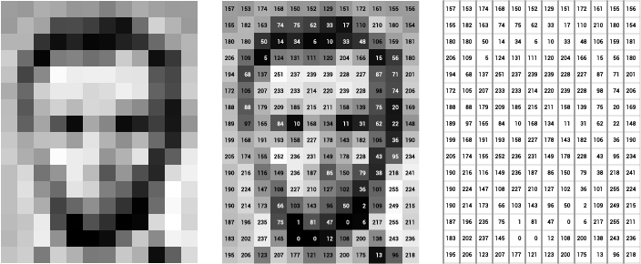

COLOR - SPACE:

For considering the 3d Tensor might be tough but by using the algorithm to convert the color space from RGB to LAB we will have a 2d Tensor of green-red and blue-yellow

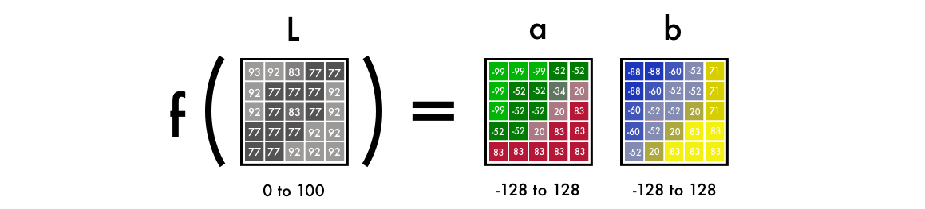

a Lab encoded image has one layer for grayscale, and has packed three color layers into two. This means that we can use the original grayscale image in our final prediction. Also, we only have two channels to predict.

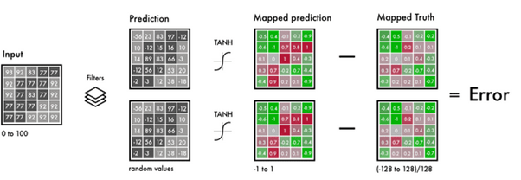

To turn one layer into two layers, we use convolutional filters. Think of them as the blue/red filters in 3D glasses. Each filter determines what we see in a picture. They can highlight or remove something to extract information out of the picture. The network can either create a new image from a filter or combine several filters into one image.

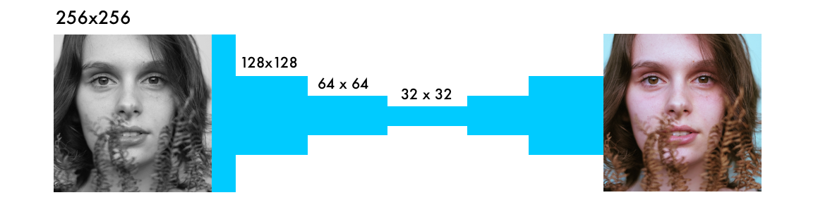

GRAY SCALED PREDICTED ORIGINAL

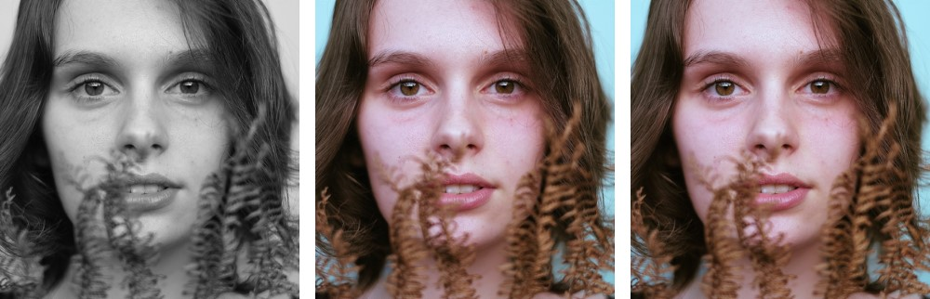

FLOW OF WORK-

[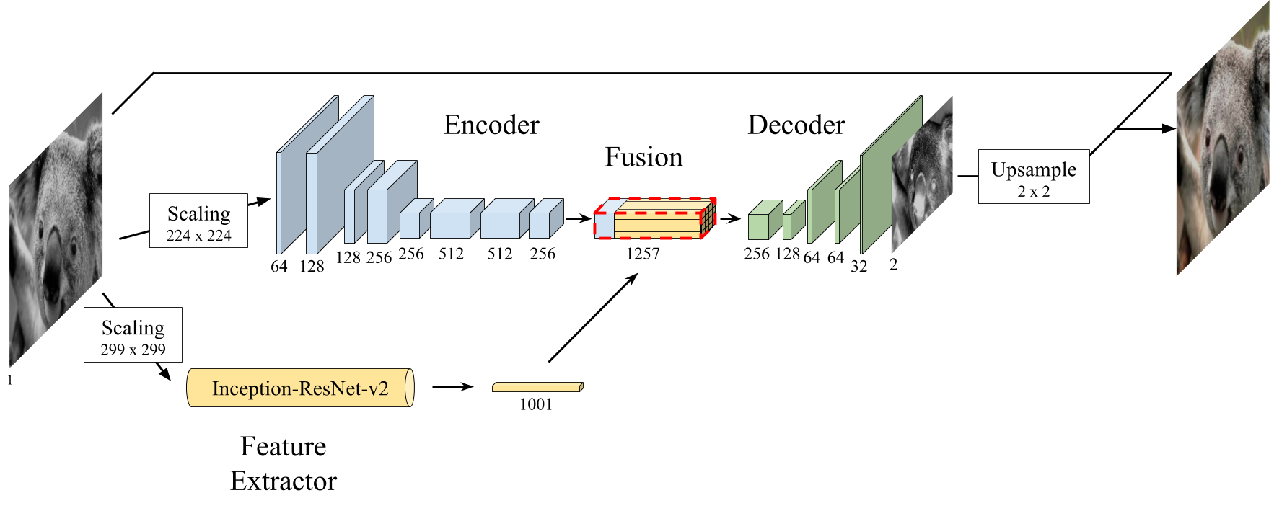](https://github.com/baldassarreFe/deep-koalarization/blob/master/assets/our_net.png)

Final Version Code and implemented it and got even worse results as we required a GPU support to this and we had the Google Support of 12Gb GPU.

We review some of the most recent approaches to colorize gray-scale images using deep learning methods. Inspired by these, we propose a model which combines a deep Convolutional Neural Network trained from scratch with high-level features extracted from the Inception-ResNet-v2 pre-trained model. Thanks to its fully convolutional architecture, our encoder-decoder model can process images of any size and aspect ratio. Other than presenting the training results, we assess the "public acceptance" of the generated images by means of a user study. Finally, we present a carousel of applications on different types of images, such as historical photographs.

Finally colored the black and white image using FastAI.

So, what’s else could be the solution?

THE UNET SAVER-

We finally knew that by only using CNN and UpSampling the given image repeatedly won’t work and we have to go through GAN (Generative Adverserial Networks).

We found that Cyclic GAN are the only solution to our problem through which we can achieve something

So, we started to explore FastAI ‘s GAN library and found UNET learner which can be used to do our work which is combination of Convolutional Neural Networks and De-Convolutional layers.

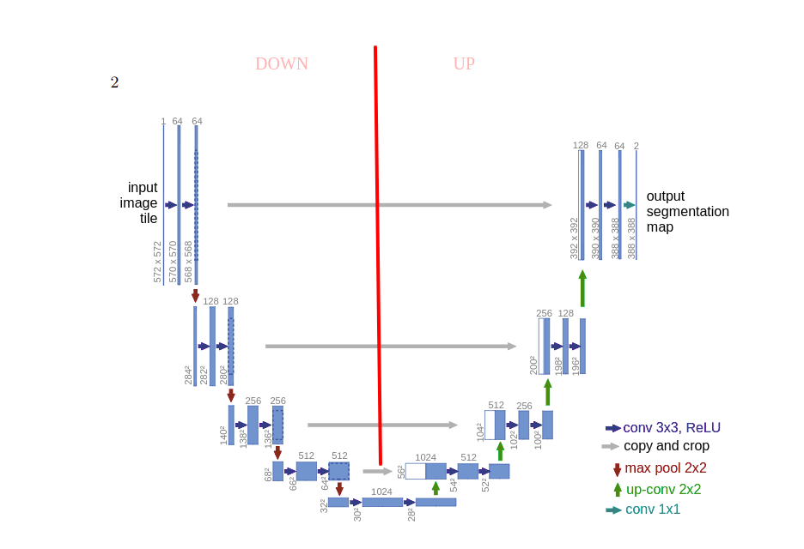

Final Results:

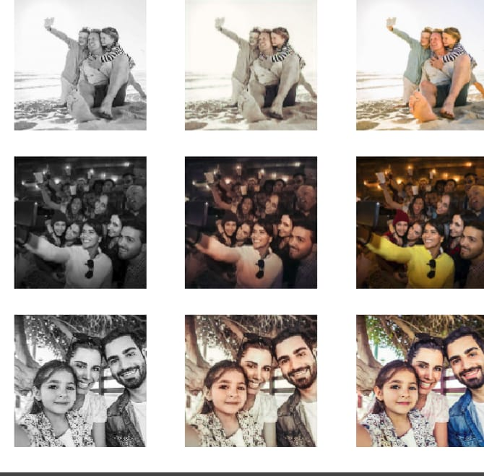

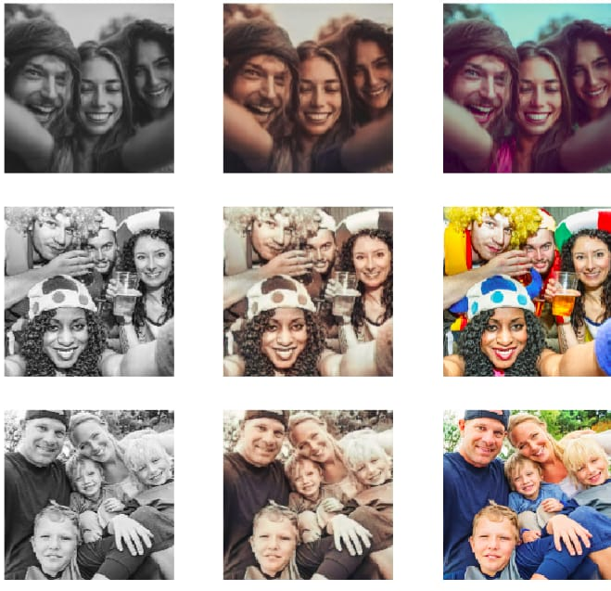

**What’s our further plans towards this project?**

We plan to move further on to colorize any image but we now know that to do this we don’t have enough computing power so Emil Wallner has agreed to help us on this matter and we might EXTEND this project as intended to do.